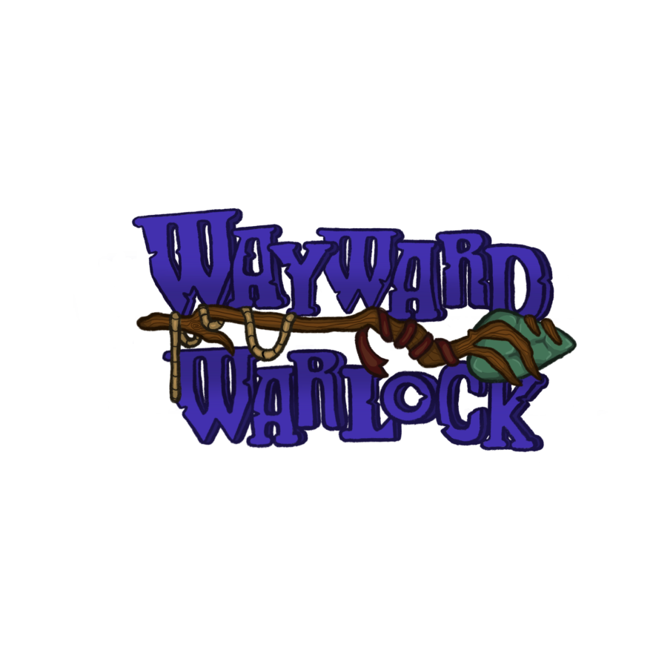

# **Summary**

You play as the final warlock of a guild, Wey, and must fight the endless onslaught of elemental golems while using their own power against them at any cost to survive.

# **Core Goals/Player Objectives**

The player’s objective is to survive as long as possible defeating hordes of enemies.

# **Features**

## **Action**

The player fires a stream of magic projectiles at incoming enemies. This normal base attack does 1 damage.

Projectile is dependent on if the player has a usable powerup available.

The powerup pickup types include:

* Fire
* Ice
* Lightning

Each powerup will be visually distinct from one another by utilizing different colors and “aura” surrounding them (flames, snowflakes, lightning bolts), with the base crystals being generally the same.

## **Health**

The player has a health bar that goes down if the enemy hits the player. The player will start with 20 health.

The golem enemies also have health, although their health bar is not visible in the same way that the player’s is in the UI. With a normal attack, it will take 2 hits to kill an earth golem, 3 hits to kill a lightning golem, 4 hits to kill a fire golem, and 5 hits to kill an ice golem.

## **Score Counter**

As the player kills enemies they will be added to the kill counter. As well as time will be continuously going up as you start the game. Once the player dies they will get to see the amount of golems slayed and the amount of time survived.

## **Enemies**

There are 4 different types of enemies.

* Earth golem: basic enemy that has a neutral attack. It takes 2 hits to kill this golem with a normal attack. It takes 1 hit to kill this golem with a special powerup.
* Lightning golem: fastest enemy. It takes 3 hits to kill this golem with a normal attack. It takes 2 hits to kill this golem with a special powerup.
* Fire golem: will do increased damage towards the player. It takes 4 hits to kill this golem with a normal attack. It takes 3 hits to kill this golem with a special powerup.
* Ice golem: slowest enemy that also slows the player down if it gets too close. It takes 5 hits to kill this golem with a normal attack. It takes 4 hits to kill this golem with a special powerup.

## **Behaviors**

All enemies will head towards the player. They will use a nav mesh to avoid obstacles. Each enemy will have a different speed and damage amount.

## **Spawning**

There are multiple spawn points across the map. There will be a spawn manager to determine what spawn points are closest to the player. It will also delegate how many of what type of golem to spawn. They will preferably be hidden in the world’s environment.

# 

# **Stretch Goals**

* Create the Forbidden Spell that wipes the screen
* Creating a Custom Animation for the Forbidden Spell
* Creating multiple animations for the wizard and every Golem.
* Adding a secondary effect to the temporary special skills

Example: The Lightning special attack would chain through enemies.

# **Power-Ups**

Each enemy drops a powerup relative to the Golem’s element type. The player holds one powerup at a time, which will be used whenever the player sees fit. These are not stackable, so the player must use their currently held powerup to be able to pick up another.

Every kill adds to the special attack meter, which once full, allows the player to use the Forbidden spell. It takes 150 kills to fully fill this bar up.

# **Theme**

The theme is a medieval fantasy shooter, based on a warlock trying to survive waves of elemental enemies.

# **Style and Gameplay Examples**

The gameplay is similar to the game *Vampire Survivors*, in the aspect of an aerial camera view of the player. The player fights an endless horde of golems that have different effects that are based on their element.

The style of the assets in the game is similar to those in the game Death’s Door. The assets will be lower poly, stylized assets, with a lot of stonework incorporated into it to give it a medieval feel.

# **Controls**

WASD controls the player’s position on screen, with the camera fixed at an angle above the player. The wizards front facing vector will always be towards the mouse position. Left mouse button will allow the player to fire in whichever direction they chose.

# **Game Design Examples:**

